DATA DASHBOARD COMPETITION
Brazilian E-Commerce (Olist) Analysis | Participant Handout

1. Competition at a Glance
Item | Details
Duration | 90 minutes
Team size | 3 to 4 members
Dataset | Olist Brazilian E-Commerce (9 CSV files, about 99,000 orders, 2016 to 2018)
Task | Answer 8 KPI questions and 10 visual questions, and combine everything on one single-page dashboard
Tool | Any dashboard tool you are comfortable with (Power BI, Tableau, Excel, Looker Studio). The worked example in Section 7 uses Power BI.

2. Dataset Guide
Use the files below. Each row lists the table, what it holds and the column that links it to other tables.
File | What it contains | Key columns
olist_orders_dataset | One row per order: status and all timestamps | order_id, customer_id
olist_order_items_dataset | Items in each order: price, freight, seller | order_id, product_id, seller_id
olist_order_payments_dataset | Payment type, instalments and value per order | order_id
olist_order_reviews_dataset | Review score (1 to 5) for each order | order_id
olist_customers_dataset | Customer city and state | customer_id, customer_unique_id
olist_sellers_dataset | Seller city and state | seller_id
olist_products_dataset | Product category and size details | product_id
product_category_name_translation | Category names in English | product_category_name
olist_geolocation_dataset | Latitude and longitude by zip prefix (optional, only for maps) | zip_code_prefix

How the tables connect
- orders links to order_items, payments and reviews through order_id.
- orders links to customers through customer_id.
- order_items links to products through product_id, and to sellers through seller_id.
- products links to the translation table through product_category_name.
Tip: customer_id is created fresh for every order. To count real people, use customer_unique_id.

3. Ground Rules
- Revenue means the sum of price in order_items for orders whose status is delivered only. Do not add freight.
- Orders and customers are counted on all orders unless a question says otherwise.
- Use the English category name (from the translation table) on every chart.
- For all trend charts, use the period January 2017 to August 2018. Months outside this range have very little data.
- Top-10 charts must be sorted from highest to lowest.
- The dashboard must be a single page with a title, a KPI row at the top, and at least two filters (for example Year and Customer State).
- If you make an assumption, write it in a small text box on the dashboard.

4. Section A: KPI Cards (8 questions)
Each KPI must appear as a card at the top of the dashboard. Each is worth 1 mark.
No. | KPI | Tables needed
K1 | Total orders | orders
K2 | Total revenue (delivered orders, price only) [SOLVED in Section 7] | orders, order_items
K3 | Average order value (total revenue / number of delivered orders) | orders, order_items
K4 | Total unique customers (use customer_unique_id) | customers
K5 | Average review score | reviews
K6 | Average delivery time in days (purchase date to customer delivery date) | orders
K7 | On-time delivery % (delivered on or before the estimated date) | orders
K8 | Total number of sellers | order_items or sellers

5. Section B: Dashboard Visuals (10 questions)
Each visual is worth 1 mark. Choose the chart type given in brackets, or a better one if you can explain why.

Sales trends
Q1. Show monthly revenue. (line chart) [SOLVED in Section 7]
Q2. Show monthly order count. (column chart)
Q3. Which day of the week has the most orders? (bar chart)

Products
Q4. Show the top 10 product categories by revenue. (bar chart)

Customers and geography
Q5. Show the top 10 states by number of customers. (bar chart)
Q6. Show revenue by customer state on a map, or as a ranked bar chart if your tool has no map.

Payments
Q7. Show the share of each payment type. (pie or donut chart)

Delivery and reviews
Q8. Show the distribution of review scores from 1 to 5. (column chart)
Q9. Show the average delivery days by customer state (10 slowest states).

Sellers
Q10. Show the top 10 sellers by revenue. (bar chart)

6. Marking Scheme (25 marks)
Part | Marks | Notes
Section A: KPIs (8 x 1) | 8 | Value must match the ground rules
Section B: Visuals (10 x 1) | 10 | Correct data, sorted, titled, labelled axes
Dashboard design and readability | 7 | Layout, colours, filters, no clutter

After submission, each team will have a short viva (about 5 minutes). The examiner will pick two charts and ask why you chose that chart type and what it tells the business. All team members should be able to explain every part of the dashboard.

7. Worked Example (K2 and Q1 solved step by step)
The two items below are solved to show the method you can follow for the rest. You must still place both on your own dashboard. The steps use Power BI Desktop. If you use another tool, the logic (load, relate, filter on delivered, group by month) is the same.

Step 0: Prepare the data (do this once)
- Load the files. Open Power BI Desktop. Go to Home > Get data > Text/CSV. Select olist_orders_dataset.csv and click Transform Data. Repeat for order_items, customers, products, payments, reviews, sellers and the translation file (you can select several files in turn and load all of them).
- Fix data types. In Power Query, select the column order_purchase_timestamp in the orders table and set its type to Date/Time (Transform > Data Type). Do the same for the other timestamp columns you plan to use. Confirm that price in order_items is a Decimal Number.
- Apply the changes. Click Home > Close & Apply.
- Check relationships. Open Model view (left panel, third icon). Power BI usually creates the links automatically. Make sure these exist:
- orders[order_id] to order_items[order_id] (one to many)
- customers[customer_id] to orders[customer_id] (one to many)
- orders[order_id] to payments[order_id] and to reviews[order_id] (one to many; if reviews shows many to many, see the note below)
- products[product_id] to order_items[product_id], and sellers[seller_id] to order_items[seller_id]
Note: the filter direction should be Single, flowing from the "one" side (for example orders) to the "many" side (order_items). This is what lets a filter on order status change the revenue.

Worked KPI: K2 Total Revenue (delivered orders)
Goal: one card showing the sum of price for orders with status "delivered".

Logic
Price lives in order_items, but the order status lives in orders. Because the two tables are related by order_id, a condition on orders[order_status] automatically filters order_items.

Steps
- Go to Report view. In the Data pane, right-click the order_items table and choose New measure.
- Type the formula below in the formula bar and press Enter:
Total Revenue = CALCULATE( SUM( order_items[price] ), orders[order_status] = "delivered" )
- From the Visualizations pane, click the Card icon. An empty card appears on the canvas.
- Drag the measure Total Revenue from the Data pane into the Fields box of the card.
- Format the card: select the card, open the Format pane (paint roller icon) > Callout value > Display units = Millions, Value decimal places = 2.
- Turn on the card Title and type "Total Revenue (R$)". Place the card in the KPI row at the top of the page.

Check your answer
Expected result
The card should show R$ 13.22 M.
Quick validation: if you remove the "delivered" condition, the sum becomes about R$ 13.59 M. The difference is the revenue from orders that were cancelled, unavailable or not yet delivered. Always use the version with the condition.

Worked Visual: Q1 Monthly Revenue (line chart)
Goal: a line chart with months on the X axis and Total Revenue on the Y axis, for January 2017 to August 2018.

Logic
A line chart needs one point per month. The orders table only has an exact purchase timestamp, so we first create a column that holds the first day of the month, then plot the existing Total Revenue measure against it.

Steps
- In the Data pane, right-click the orders table and choose New column.
- Enter this formula and press Enter:
Order Month = DATE( YEAR(orders[order_purchase_timestamp]), MONTH(orders[order_purchase_timestamp]), 1 )
- With the new column selected, go to Column tools and set the format to "MMM YYYY" (or any month-year style you like).
- Click an empty area of the canvas and select the Line chart visual.
- Drag Order Month from the orders table into the X-axis box. If it appears as a Date Hierarchy (Year, Quarter, Month, Day), click the small arrow next to the field and choose Order Month instead, so you get one continuous line.
- Drag the measure Total Revenue into the Y-axis box.
- Limit the period: in the Filters pane, find "Order Month on this visual", set the filter type to Advanced filtering, and enter: is on or after 01-01-2017 AND is on or before 01-08-2018. Click Apply filter.
- Format the chart: add the title "Monthly Revenue (Delivered Orders)", give the X axis the title "Order month" and the Y axis the title "Revenue (R$ millions)", and set the Y axis display units to Millions.
- Optional: switch on data labels or markers so the highest and lowest months are easy to spot.

Check your answer
Your chart should look similar to the picture below. Revenue starts low in early 2017, rises steadily, jumps sharply in November 2017, and then stays at a higher level through mid 2018.
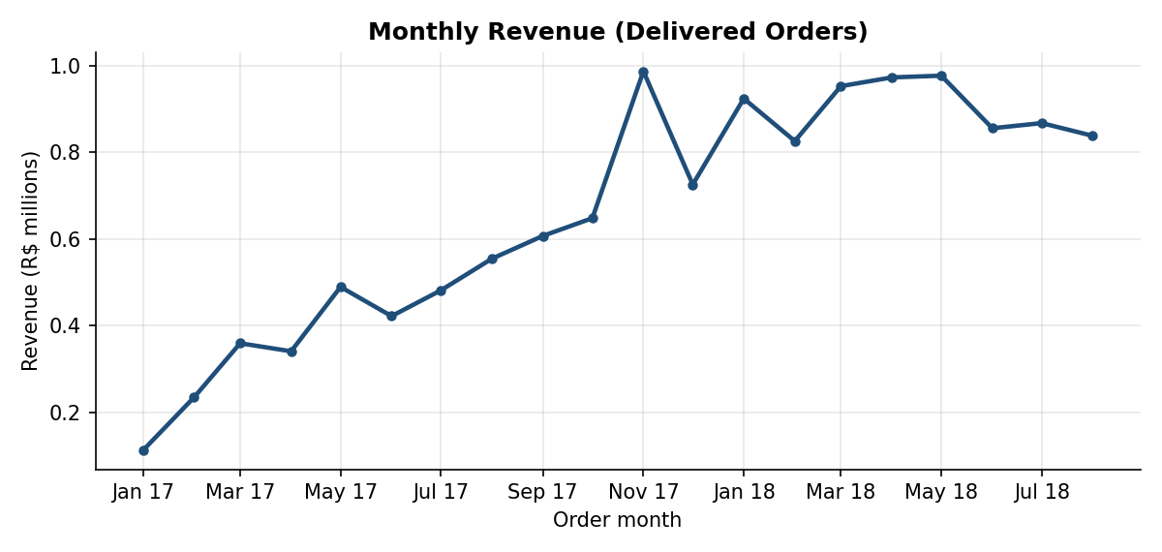
Expected output for Q1
How to read this chart (example of a good insight)
Monthly revenue grew from about R$ 0.11 M in January 2017 to about R$ 0.99 M in November 2017, which is the highest point in the whole period. The spike is likely linked to the Black Friday sales period.
From January 2018 onwards revenue stays between roughly R$ 0.83 M and R$ 0.98 M per month, so growth has levelled off.

Using Excel instead?
Load each CSV with Data > Get Data > From Text/CSV and choose Load To > Data Model. Create the same relationships in Manage Data Model, then insert a PivotTable from the Data Model. For K2, put price from order_items in Values and add a filter on order_status = delivered. For Q1, put the purchase date in Rows (group by Years and Months) and insert a PivotChart (Line).

Good luck!

